Design Specification
For
Customer Valuation Form in Finance Enterprise

Author | ______________________________ | Date | ____________
Vimal Kumar
Business Analyst
Reviewer | _______________________________  Amit Sanandiya  Project Manager | Date | ____________
Reviewer | _______________________________  Chris Silveira  Credit Control Manager | Date | ____________
Approver | _______________________________  Shiva Kottam  QA Officer/RP | Date | ____________

1. Introduction
The Finance Enterprise system is the core financial management platform used by B&S for managing customer accounts, credit limits, payment processing, and financial reporting.
This enhancement introduces a Credit Valuation Automation feature that integrates with Credit Safe API to streamline the credit assessment process for both existing and new customers. The feature will be accessible via a new "Customer Valuation" sub-menu under the Customer menu.
The change is controlled through CC25-0367.

2. Scope
The scope of this design covers all UI components and interactions required to support the Credit Valuation Automation feature, including:
- Customer Valuation Menu Integration
- Search Interface for Existing and New Customers
- Valuation Display with three-column layout
- Credit Safe Integration and Display
- Account Details Tab with rolling 12-month data
- Export Functionality for Excel and PDF

3. Design Specification
This section contains the design specifications corresponding to the URS requirements for adding customer valuation form features to the Finance Enterprise.

3.1 Existing Customer Valuation Screen
The main valuation screen displays customer data, prescription information, credit position, Credit Safe data, and calculated valuation results.
Main Screen
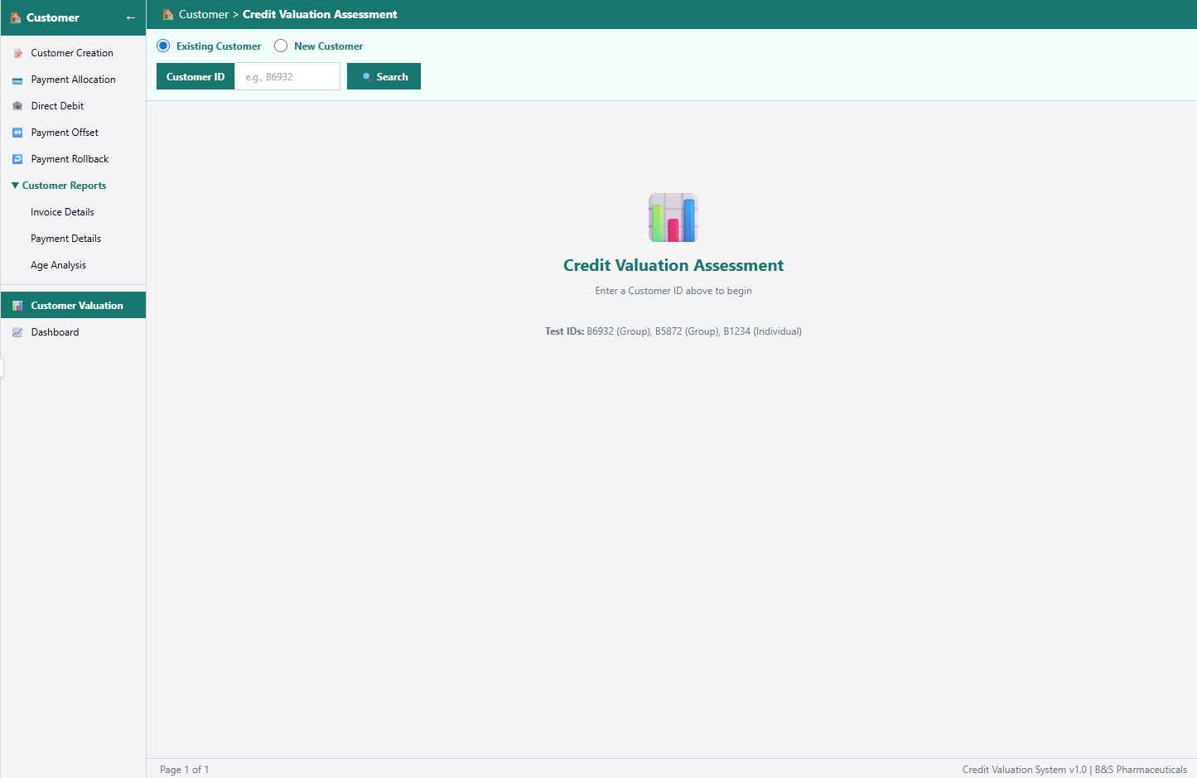
Existing Customer Screen
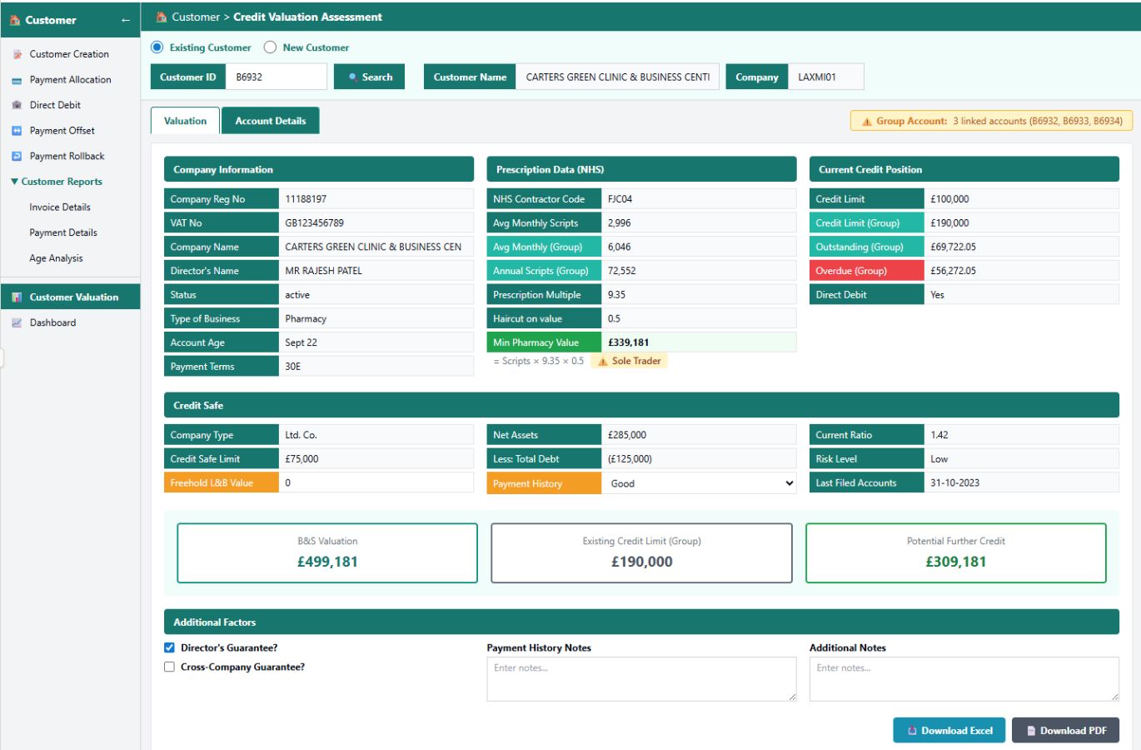

3.2 Existing Customer - Account Details Tab
The Account Details tab displays a detailed table of linked accounts with rolling 12-month payment history. This tab is only visible for existing customers.
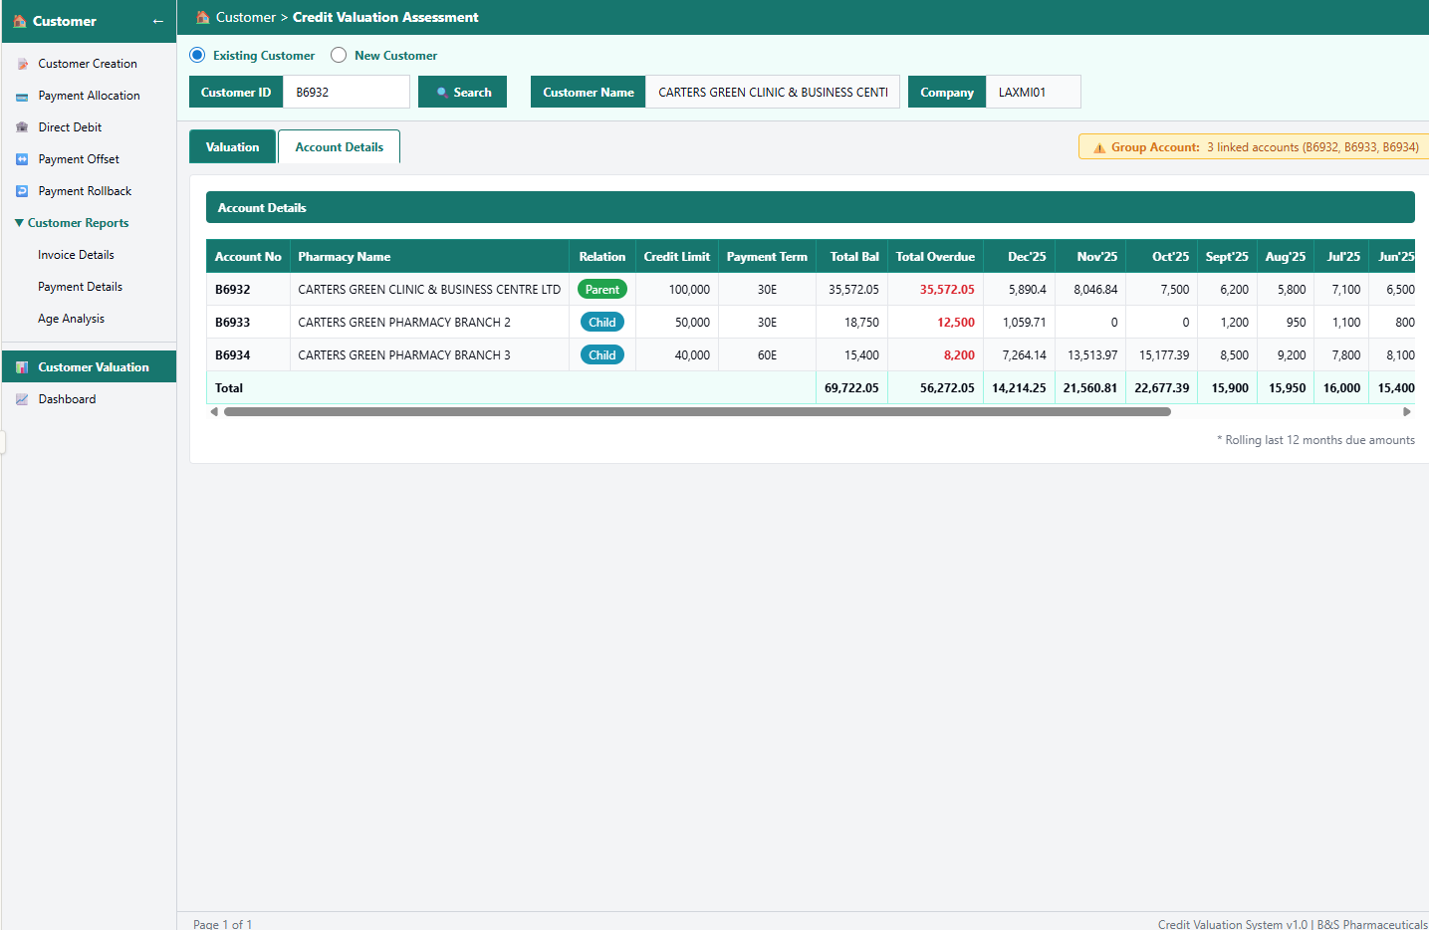

3.3 New Customer
When the user selects "New Customer" mode, the search interface changes to accept Company Registration Number and VAT Number instead of Customer ID
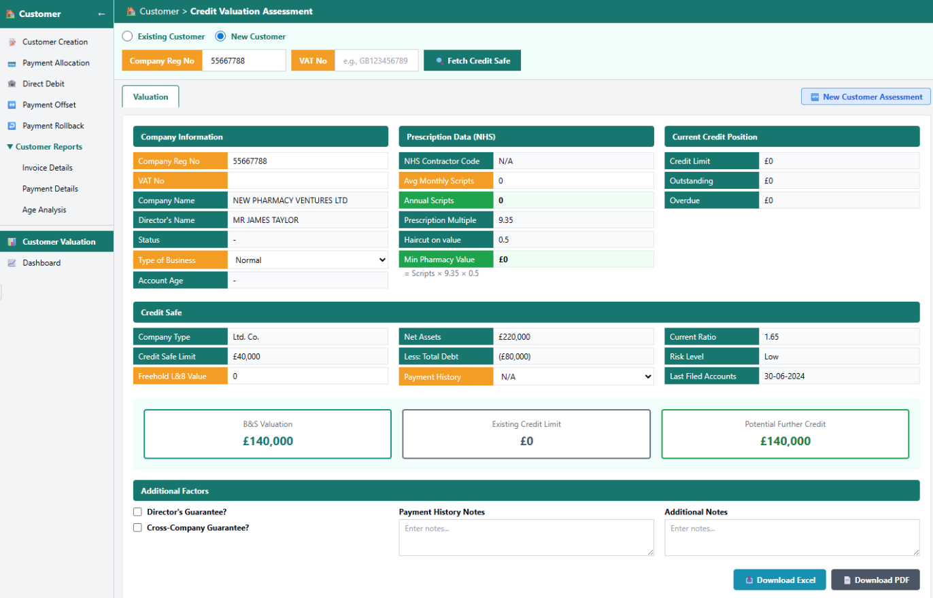

4. Non-functional Specifications
This section contains all non-functional associated with the development and implementation.

4.1 Availability
The system should be available online 24*7*365 services, except scheduled and pre-notified system maintenance downtimes.
Data should become immediately available for use, both during input and for reporting unless otherwise negotiated with the IT Hardware Team. The IT Hardware Team will ensure that system resources are adequate for timely report generation response times and overall software functionality. The IT Hardware will ensure that regular system maintenance is not completed during peak operation periods.
4.2 Capacity Limits
There is no limit on the number of transactions or concurrent users. However, there must be a facility that 2 or more users cannot change the same action concurrently.

4.3 Performance
Checking the fact that the system should perform as every user expects. So, in every action-response of the system, there are no immediate delays.
Assuming 100 customers are working simultaneously, a quick response should be given.

4.4 Recoverability
For data and file recoverability, our Database Administrators and Network Administrator periodically perform taking backup practice. From that, backup, important data and files will be recoverable at any time.
4.5 Security requirements
The system is hosted on B&S server at the Perivale site. Server rooms are access controlled to prevent unauthorized access and are protected by firewalls to ensure data security. All users are allocated a unique username and password and all actions are recorded within an audit trail.
4.6 Error Handling
Error handling will be incorporated in to the system to reduce the occurrence of erroneous data. Error traps and data validation will be incorporated and pop-up messaging and error reports will clearly identify what has happened and suggest a means of resolution.

4.7 Usability
The system will be subject to user acceptance testing as part of the development process to ensure the user experience meets the requirements.
4.8 Accuracy & Validity
The system will employ numerous data quality assurance techniques, including but not limited to:
- Input masks (i.e., Textbox allow only number)
- Drop down lists with standard responses
- Record data completeness requirements
- Basic data logic warnings (i.e., Approved quantity not greater than original quantity).

5 Revision History
Version | Previous version | Reason for revision | Issued
1 | N/A | Automate the credit valuation process by integrating Credit Safe data and data from Finance Enterprise by adding a new sub-menu item "Customer Valuation" under the Customer menu in Finance enterprise as per the CC25-0367 | Jan 2026

